

**WELCOME**

We are pleased to welcome you to our practice. Please take a few minutes to fill out this

form as completely as you can. If you have any questions, we’ll be glad to help you.

We look forward to working with you in maintaining your dental health.

**PATIENT INFORMATION**

Patient’s Name ________________________________________________________________ Social Sec. #__________________

Last Name First Name Middle Initial

Address__________________________________________ City_______________________ State__________ Zip____________

Home Phone # ____________________Cell Phone # _________________________Work Phone #_________________________

Email____________________________________________________________________________________________________

Sex  M  F Age___________ Birthdate____________________ Single Married  Widowed  Divorced

Patient Employed by_________________________________________ Occupation ____________________________________

Whom may we thank for referring you? ________________________________________________________________________

In case of emergency who should be notified? _________________________________ Phone # __________________________

**DENTAL INSURANCE**

Person Responsible for Insurance ____________________________________________________________________________

Last Name First Name Middle Initial

Relation to Patient __________________________ Birthdate _________________ Soc. Sec. #___________________________

Address (If different from patient’s ___________________________________________________________________________

City____________________________________ State_____________ Zip_____________ Phone #________________________

Person Responsible Employed By_____________________________________________________________________________

Insurance Company______________________________________ Subscriber’s ID #____________________________________

Group #_________________________________________ Insurance Company’s Phone # _______________________________

Is patient covered by additional dental insurance?  Yes  No

**If yes, please complete the following secondary insurance information.**

Insured’s Name ___________________________________________ Relation to Patient _______________________________

Insured’s Soc. Sec. # _______________________________________ Insured’s Birthdate _______________________________

Insurance Company________________________________________ Subscriber’s ID #__________________________________

Group #________________________________________ Insurance Company’s Phone # ________________________________

380 Merrimack St, Ste 3C Methuen, Ma 01844

Tel 978-681-7740 Fax 978-681-5018 office@dentistsmethuen.com



**DENTAL RECORDS RELEASE FORM**

I, ______________________________________________, authorize the release of my dental records to the office of Torrisi, Burba &Maripuri Dental Associates.

____________________________________________ ____________________________________________

Date: Patient Signature:

Please forward to: office@dentistsmethuen.com

380 Merrimack St, Ste 3C Methuen, Ma 01844

Tel 978-681-7740 Fax 978-681-5018 office@dentistsmethuen.com



**ACKNOWLEDGEMENT OF RECEIPT OF NOTICE OF PRIVACY PRACTICES**

*You May Refuse to Sign This Acknowledgement*

I, ___________________________________________, have received a copy of this office’s Notice of Privacy Practices.

(Please Print Name)

____________________________________________ ____________________________________________

Date: Patient Signature:

For Office Use Only

We attempted to obtain written acknowledgement of receipt of our Notice of Privacy Practices, but acknowledgment could not be obtained because:

Individual refused to sign

Communications barriers prohibited obtaining the acknowledgement

An emergency situation prevented us from obtaining acknowledgement

Other (Please Specify)

__________________________________________________________________

__________________________________________________________________

380 Merrimack St, Ste 3C Methuen, Ma 01844

Tel 978-681-7740 Fax 978-681-5018 office@dentistsmethuen.com



**OFFICE POLICY AND PROCEDURE**

Thank you for choosing Torrisi, Burba & Maripuri Dental Associates. Our primary mission is to deliver the best and most comprehensive dental care available. Our fee is based on the quality materials we use and the time, effort and skill required in performing your treatment. They are reasonable and customary to our area. An important part of the mission is making the cost of optimal care as easy and manageable for our patients as possible by offering payment options. We accept cash, check, Visa, Mastercard, American Express or Discover Card. For extensive cases/treatment we offer usage of a convenient monthly payment option from Care Credit Healthcare Credit Card. This option allows you to pay overtime with no annual fees or pre-payment penalties. Please ask our front office staff for details.

Payment is due at the time services are rendered. For patients with dental insurances, we are happy to work with your carrier to maximize your benefit and directly bill them electronically for costs of your treatment. Your estimated copayments are due on the date of service.

For all patients with dental insurance, most dental insurances do directly reimburse the dentist, some may only remit payment to the patient. In this case, the patient is responsible for providing payment in full to the office and we will file a claim on your behalf to your carrier for reimbursement.

Should any balance remain unpaid after 60 days or should you violate the terms of your payment agreement, we reserve the right to refer our account to our collection agency. Any fees associated with the collection of these delinquent accounts will be the direct responsibility of the patient.

For the respect of our staff and other patients, we require at least 48 hours notice should you need to cancel/reschedule an appointment. This allows us sufficient time to contact a patient who may be waiting to be moved up into the schedule. Please be advised that at the discretion of the office a fee of $60.00 or more depending on length of appointment, may be applied to your account if not canceled with 48 hours. There will be a $40.00 fee for any returned checks.

We respectfully request that all minors be accompanied by an adult. This allows the staff to make informed decisions regarding the patient’s care. If you are unable to accompany your child to his or her appointment, you must provide a phone number where you can be reached should the need arise.

MassHealth patients please be aware multiple no shows or canceled appointments will be reported to M.H.

Please feel free to contact our office with any questions or concerns and our qualified staff will be happy to assist you.

________________________________________ _____________________________

PATIENT SIGNATURE: DATE:

380 Merrimack St, Ste 3C Methuen, Ma 01844

Tel 978-681-7740 Fax 978-681-5018 [office@dentistsmethuen.com](mailto:office@dentistsmethuen.com)

Burba and Maripuri PLLC

DENTISTSMETHUEN.COM OFFICE@DENTISTSMETHUEN.COM

380 Merrimack street | Suite 3C • Methuen, MA 01844 (978)681-7740

**Patient Name:**

Last First MI Preferred Name

**Please select/verify the following medical alerts:**

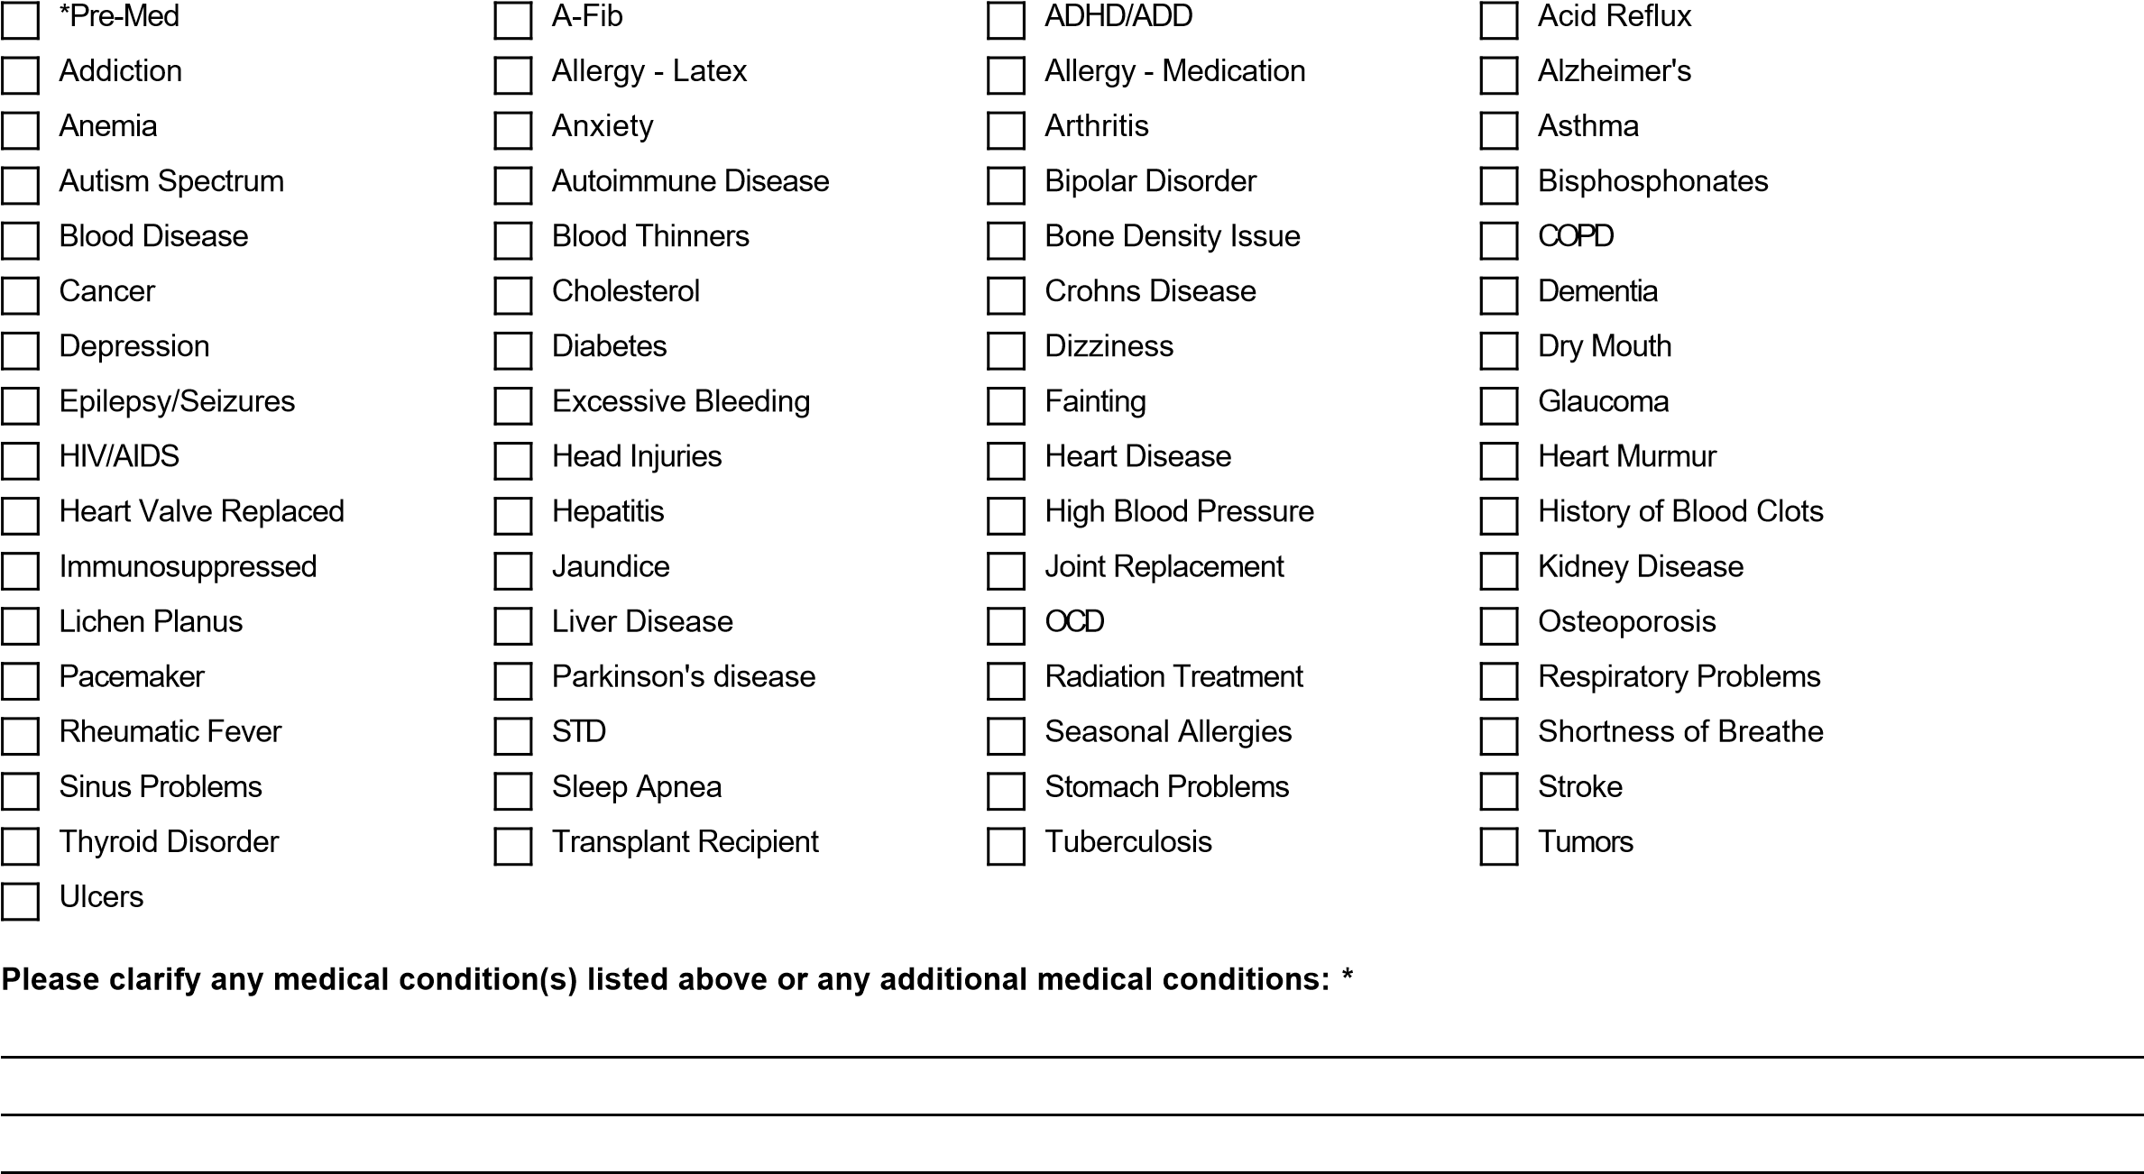

**Please list any additional allergies including allergies to medications and environmental and food: *\****



**Please list all current medications: *\****

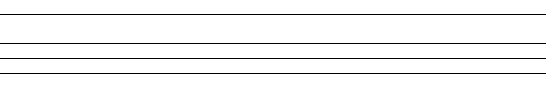

**Primary care physcian name, telephone, location: *\****



Page 1 of 2

**Tobacco use/ history: *\****



**Alcohol consumption: *\****



**Recent Hospitalization or Major Illness or Surgery: *\****



**Do you have any artificial joints or hear valve replacements? If yes, please describe: *\****



**Do you require premed antibiotics prior to dental procedures? If yes, please explain. *\****



**Please select if any of the following apply?**

***\****

**WOMEN ONLY/ Please select if any of the following apply:**

**Preferred Language:**



**Additional Notes:**

Snoring

CPAP use

Daytime sleepiness

Wake up at night gasping for air

NONE OF THE ABOVE

Pregnant

Nursing

Taking birth control pills

NONE OF THE ABOVE

**Response Date:**

